**Grouping Products Insert:**

This insert uses JavaScript to collect all of the products in a category and combine them based on the root product name. Links will be created to each unique product based on what is contained within parenthesis at the end of the product name.

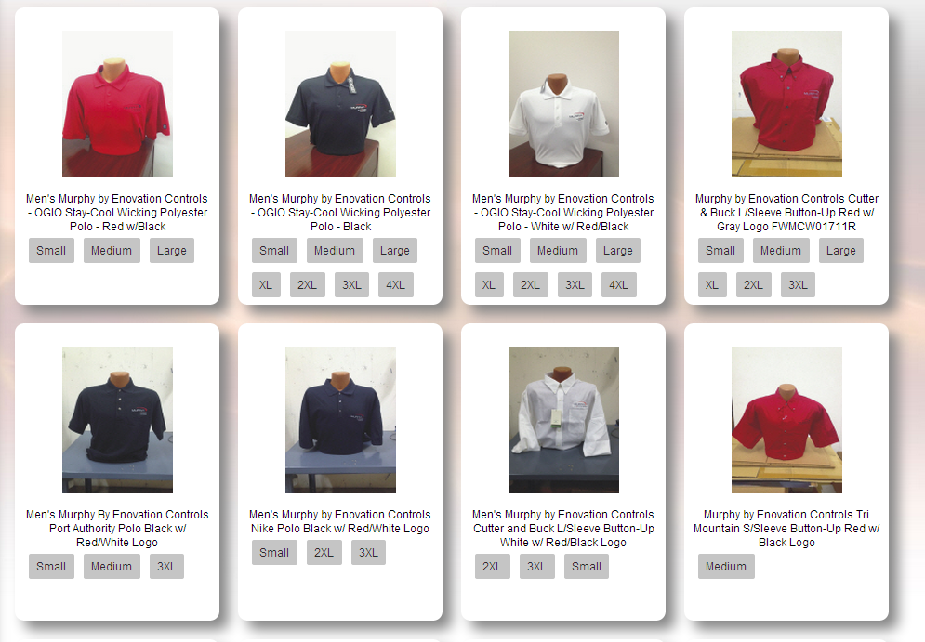

Below are example products to be grouped into a single product:

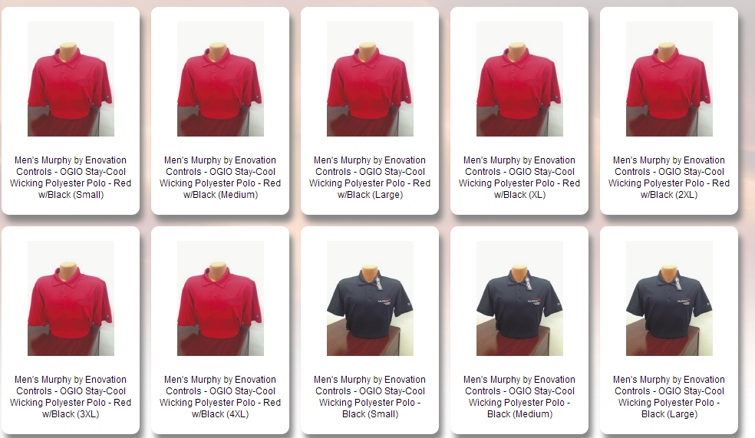

After uploading the insert, it reduces the products to a single item with 3 links. Each link will still take the user to the unique product, but it simplifies the category page and user navigation.

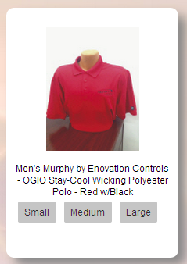

**Implementation:**

1. Button text is at the end of the product name, inside parenthesis. Example: (Large)
2. Any text can be used. Examples: (Large) (s) (2010 Annual Report)
3. To group products together, the root name before the parenthesis must be **EXACTLY** the same.
4. If a product’s name does not have any text in parenthesis, a button will appear called “All Options”.
5. If a product is in that category and is going to have only one option, the button display name can still be put in parenthesis to use something other than “All Options”. It will look like the below image:

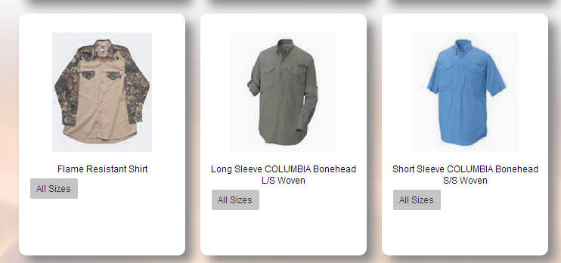

All implementations:

1. Download the file: Category_shirts_Top.html
2. Modify CSS to match the site’s colors. If not modified, it will look similar to the screenshots.
3. Ensure jQuery is loaded in the SiteHeader.html or other insert before this loads.

**To implement on a single Category:**

1. Change the filename to match the desired category. For example to apply this to the ‘apparel’ category, change the insert name to “Category_apparel_Top.html’.
2. Upload the insert to the desired theme’s ‘Inserts’ folder.

**To implement on multiple categories:**

1. Add a custom insert selector on the Streamline admin side on each of the categories you would like the script applied too.
   1. To apply the file to multiple categories:
      1. Go into Categories
      2. Select each desired category
      3. For the Dropdown “Category Insert Selector”, change it to “shirts” or the center part of the insert’s filename if different.
2. Upload the insert to the desired theme’s ‘Inserts’ folder.

